Weather Station Latitude Prediction
Author: Helena Ristov

The problem, as given, for this exercise was to determine and predict the latitude of some weather stations based on weather data that was collected and stored for each station. Data captured post 2020 have erroneous values of -9999 for latitude in addition to having weather stations in the dataset which are in new geographic regions over what was previously collected. Therefor the challenge is two-fold and the solution I will provide will address both problems with pipeline orchestration for automation of this solution on the cloud.
- Latitude Prediction – Predicting and assessing latitude of weather stations
- Weather Station Anomaly Detection – Identifying new weather stations in different geographic zones
- Orchestration – Automation of the model for cloud deployments.
As suggested in the challenge, my focus was not on training the best model but putting forth a solid foundation with consideration given to best practices for machine learning and cloud production deployments.
Latitude Prediction
Latitude is the horizontal marker on the globe which contributes to various weather conditions. Latitude influences climate patterns: therefore, I aggregate statistics at the station level into features for faster computing and efficiency. Each station's hourly time-series is aggregated into statistical features. The most important latitude signals based on preliminary research and corroborated in the model are that the difference in seasonal temperature and radiation (insolation) are influenced by latitude.
- seasonal temperature amplitude — near-equatorial stations have near-zero seasonal swing
- monthly temperature and radiation profiles — directly tie the sun angle and insolation pattern
In essence of time, I chose a random forest classifier and converted the -9999 sentinel values in the dataset to NaN. The random forest performs well when there are outliers with low overhead on data preprocessing. To improve on this solution, I would also examine the shape of the seasonal curve. Monthly means capturing this somewhat, but the ordering and transitions or lags between months would carry extra signal.

The top, ranked feature importances for this model are included below.
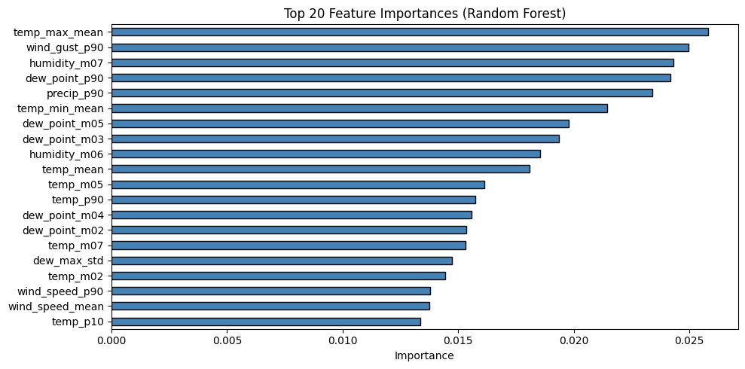
In sample R^2 is .88. Running cross validation suggests that this model is overfitting and doesn’t perform as well out of sample, so there is room for improvement, but the methodology for machine learning is sound. Cross-Validation Results: R²: 0.318 ± 0.143
Weather Station Anomaly Detection
To assess and flag which weather stations are net new and not in the training set, I use Mahalanobis distance which is a statistical, multivariate metric that measures the distance between a data point and a distribution. I flag stations whose feature vectors are beyond a certain distance from the training set. For a point with k features, the squared Mahalanobis distance follows a chi-squared (χ²) distribution but only if the data is roughly multivariate normal. This is a well-known result in multivariate statistics.
Mahalanobis distance assumes a multivariate Gaussian distribution, I include the caveat that the jointly Gaussian solution is unlikely to hold, because humidity and wind statistics are most likely to be skewed or include fatty tails. Further analysis is recommended and an isolation forest should be examined as well.
To be conservative, I use 99% confidence and the top 20 features to reduce dimensionality overfitting and increase stability. Using this approach 11 stations were flagged as potential outliers and from new geographic zones.
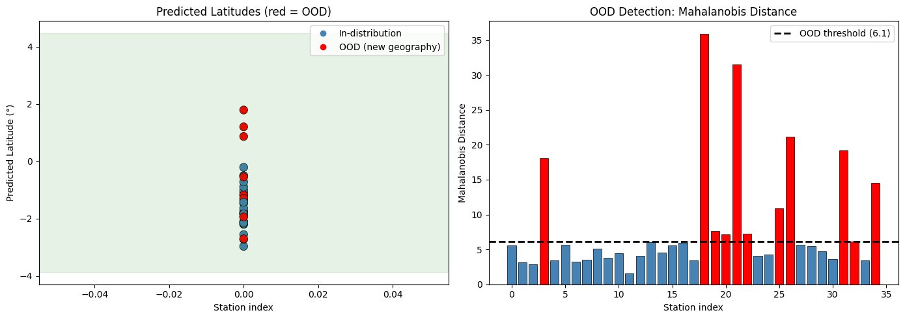
Automation and Orchestration Ready
I provide files which can be transferred and deployed to any cloud environment. On GCP I’d use Vertex AI training and Cloud Run. On AWS I’d use SageMaker Processing. On Azure I’d deploy through Azure ML with Foundry for governance and monitoring. This can be later architected to be more robust incorporating database and data formats depending on latency or other production requirements.
What each file does
Dockerfile — Installs all the required libraries (pandas, scikit-learn, etc.) inside a container. This guarantees the code runs the same way on any machine: your laptop or cloud server regardless of the operating system.
requirements.txt — The list of Python packages the Dockerfile installs. It's separate so you can also use it for local Python installs without Docker.
run_pipeline.py — This is the script that loads the data, performs feature engineering and aggregations, trains the model, predicts latitudes, detects OOD stations, and writes predictions to the prediction_results.csv which can later be stored in a database.
run.sh — a convenience wrapper for Mac/Linux. It's essentially a shortcut that runs three things in sequence: docker build, docker run, and a check that the output file was created. Without it you'd have to type docker run commands manually every time. I developed this application on a windows machine, and have therefor included instructions in the readme file for both Linux and windows.
sfl_latitude_prediction.ipynb — the analysis notebook not used in automation but used for training, visualization, and presenting results.
References:
- Pedregosa, F. et al. (2011). Scikit-learn: Machine Learning in Python. JMLR 12, 2825–2830.
- Mahalanobis, P.C. (1936). On the generalised distance in statistics. Proceedings of the National Institute of Sciences of India.
- Liu, F.T., Ting, K.M., Zhou, Z-H. (2008). Isolation Forest. IEEE ICDM 2008.
- INMET — Instituto Nacional de Meteorologia (Brazilian weather station data source).
- Claude and ChatGPT: Coding, Documentation and Formalization
- https://courses.ems.psu.edu/earth103/node/1004
- https://rinterested.github.io/statistics/mahalanobis.html

